dk;kZy; izkpk;Z] 'kkldh; MkW-ok-ok-ikV.kdj dU;k LukrdksRrj egkfo|ky;]
dsUnzh; fo|ky; ds ikl] tsyjksM nqxZ ¼N-x-½
iwoZ uke&'kkldh; dU;k egkfo|ky;]nqxZ ¼N-x-½ Qksu 0788&2323773
Email- govtgirlspgcollege@gmail.com Website: www.govtgirlspgcollegedurg.com
College Code : 1602

nqxZ] fnukad % 25-11-2019
izsl foKfIr
xYlZ dkWyst dh 6 Nk=k,¡ fo'ofo|ky; Vhe esa

'kkldh; MkW- ok-ok- ikV.kdj dU;k LukrdksRrj egkfo|ky; dh Nk=kvksa dk fo'ofo|ky;hu Li/kkZvksa esa opZLo dk;e jgk gSA egkfo|ky; dh 6 Nk=kvksa dk p;u gsepan ;kno fo'ofo|ky; dh OgkyhckWy Vhe esa gqvk gSA ØhM+k vf/kdkjh MkW- _rq nqcs us tkudkjh nsrs gq, crk;k fd 7 fnlacj ls 10 fnlacj 2019 rd dhV~l fo'ofo|ky; Hkqous'oj esa vk;ksftr gksus okyh vUrZfo'ofo|ky;hu bLV tksu OgkyhckWy Li/kkZ esa Vhe Hkkx ysxhA egkfo|ky; ls dq- euh"kk] lkfjdk ehuk] lq"kek f'k[kk] fEkUgktfo'kk] oS".koh lkgw] euizhr dkSj dk p;u gqvk gSA ;s Nk=k,¡ iwoZ esa Hkh jk"Vªh; Lrj dh Li/kkZvksa esa Hkkx ys pqdh gSA
Nk=kvksa dk izf'k{k.k dSai 'kh?kz djus gks jgk gSA Nk=kvksa dh bl lQyrk ij egkfo|ky; ds izkpk;Z MkW- lq'khy pUnz frokjh ,oa izk/;kidksa] deZpkfj;ksa us c/kkbZ nh gSA

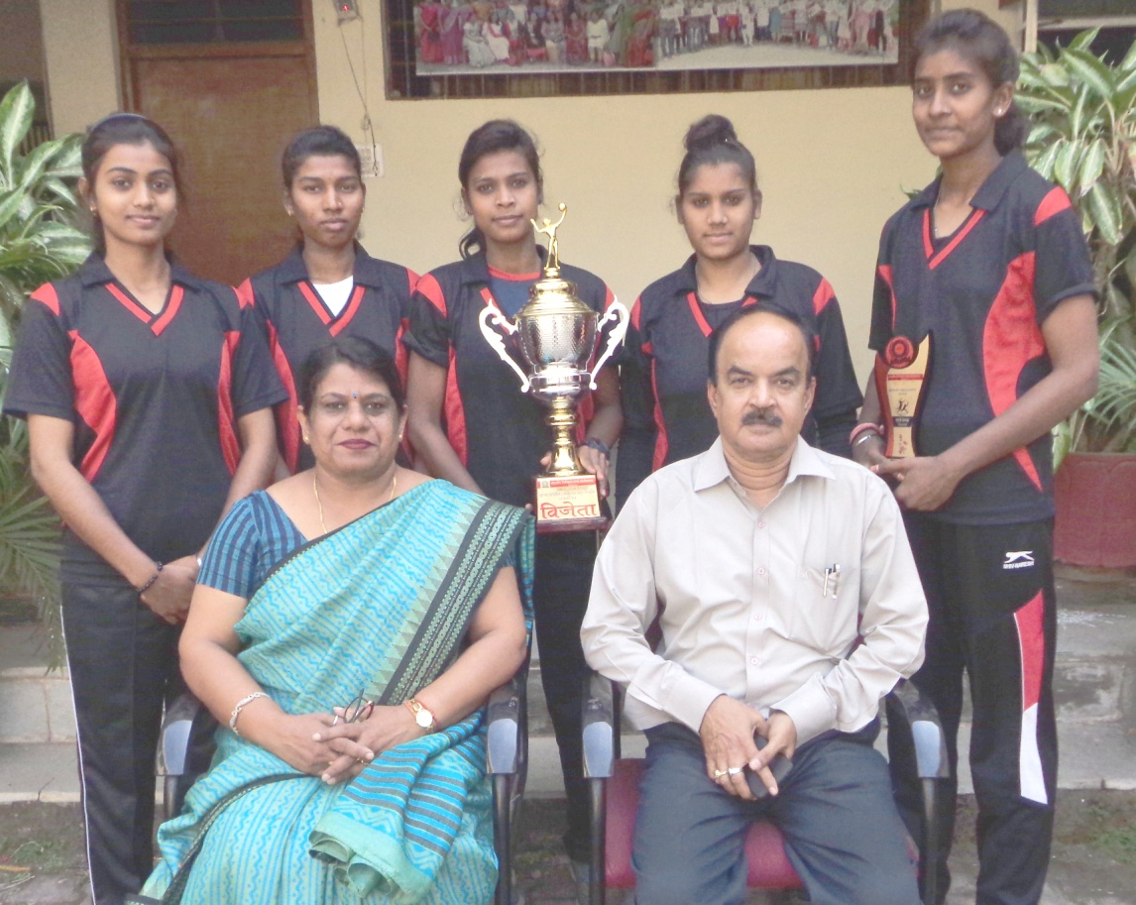

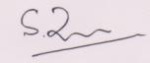
lekpkj ds :i esa izdk'ku gsrq fuosfnrA

¼MkW0 lq'khy pUnz frokjh½
izkpk;Z
'kkl0 MkW0 ok0 ok0 ikV.kdj dU;k
LukrdksRrj egkfo|ky;] nqxZ ¼N0x0½

